EXPERIMENT 5
ROLL NO: 240701520 NAME: SOAMESHWARAN D

I created my flowchart using LUCID CHART
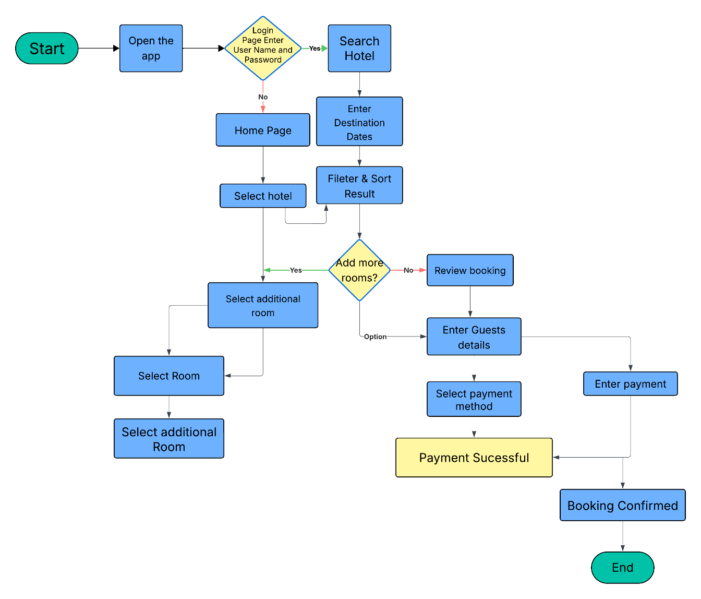

1. START
This is the beginning of the hotel booking process.
The user starts interacting with the application.
Relation with exp 4 :
This represents the moment before the user reaches Screen 1 – Sign In Page.

2. Open Hotel Booking App
The user launches the hotel booking mobile application.
Relation with exp 4:
After opening the application, the user is directed to the Sign In Page (Screen 1) where authentication takes place.

3. Login Page – Enter Username & Password
The user enters login credentials such as:
- Email / Username
- Password
This step ensures that only registered users can access booking services.
Relation with exp 4 :
This step corresponds exactly to:

Screen 1 – Sign In Page
Purpose:
To authenticate the user before allowing access to booking features.
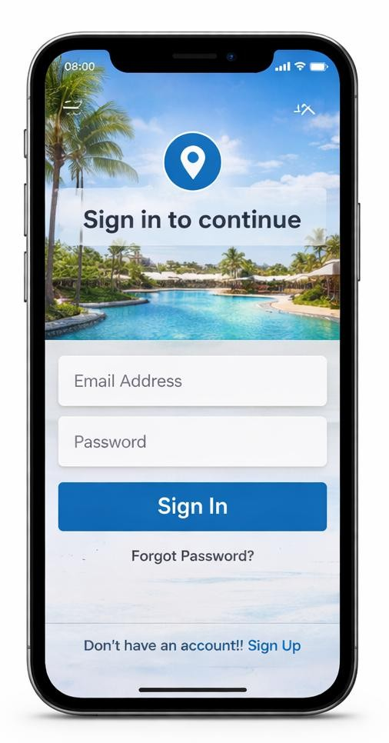

4. Login Verification (Decision)
The system verifies whether the login credentials are correct.

Two possible outcomes:

YES
If credentials are correct → user proceeds to search hotels.

NO
If credentials are incorrect → user is redirected to the Home Page or asked to login again.

5. Home Page
The home page is the main dashboard where users can explore hotels and search for destinations.
Relation with exp 4:

Screen 2 – Home Page
Purpose:
To allow users to browse hotels, explore destinations, and start the booking process.
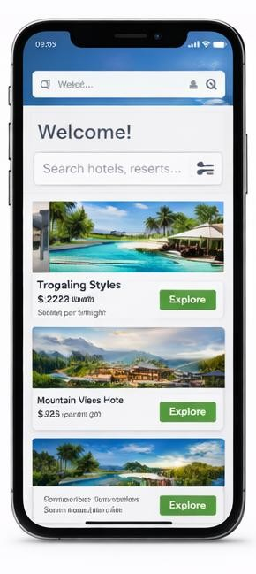

6. Search Hotels
The user selects the search option to find available hotels.
This feature allows users to locate hotels based on their preferences.
Relation with exp 4 :
This action occurs from Screen 2 – Home Page where the Search icon is available.

7. Enter Destination, Dates, Guests
The user enters booking details such as:
- Destination / City
- Check-in date
- Check-out date
- Number of guests
The system uses this information to display available hotels.
Relation with exp 4 :
This information is used when the user proceeds to booking which is later shown in Screen 7 – Booking Page.

8. Filter & Sort Results
The system shows a list of hotels that match the user's search criteria.
Users can filter results by:
- Price
- Rating
- Amenities
- Distance
- Popularity
Relation with exp 4 :
This step helps the user choose a hotel before opening the Resort Details Page (Screen 3).

9. Select Hotel
The user selects a hotel from the search results.
The system displays detailed information about the selected hotel.
Relation with exp 4:

Screen 3 – Resort 1 Details Page
Purpose:
To provide detailed information about the hotel before confirming booking.

10. Select Room
The user selects the room type available in the hotel.
Examples:
- Standard Room
- Deluxe Room
- Suite Room
This step determines the price and facilities.

11. Select Additional Room
If the user needs more than one room, they can select additional rooms.
This option is useful for group bookings or family stays.

12. Add More Rooms? (Decision)
The system asks whether the user wants to add more rooms.

YES
User selects additional rooms.

NO
User proceeds to booking confirmation.

13. Review Booking
The system shows the booking summary including:
- Hotel name
- Room type
- Number of rooms
- Booking dates
- Total price
The user reviews the details before confirming.

14. Enter Guest Details
The user enters personal information such as:
- Guest name
- Phone number
- Email address
- Special requests (optional)
This information is required for reservation confirmation.

15. Select Payment Method
The user selects the preferred payment method.
Possible methods:
- Credit card
- Debit card
- Net banking
- UPI
- Wallet payment

16. Enter Payment
The user enters payment details such as:
- Card number
- Expiry date
- CVV
- OTP verification

17. Payment Success? (Decision)
The system verifies whether the payment transaction is successful.

YES
Booking is confirmed.

NO
User must retry the payment.

18. Retry Payment
If the payment fails, the user can try again using the same or different payment method.

19. Booking Confirmed
Once payment is successful, the system confirms the reservation.
The user receives:
- Booking confirmation message
- Reservation details
- Booking ID
Relation with exp 4 :

Screen 9 – Payment Confirmation Page
Purpose:
To inform the user that the booking has been successfully completed.

20. END
This is the final stage where the booking process is completed successfully.
The user can return to the home page or view booking details.

